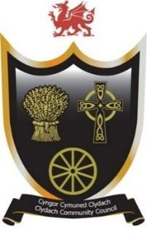
Cyngor Cymuned Clydach
Clydach Community Council
Forge Fach Community Resource Centre
Hebron Road, Clydach. SA6 5EJ
Tel 01792845566
Email clerk@clydach.wales

To Members of the Committee, you are hereby summoned to attend the meeting of the EVENTS AND PROJECT COMMITTEE
To be held at Waterfall Suite, Forge Fach Resource Centre
and as a VIRTUAL MEETING ONLINE
On Tuesday 10 March 2026, commencing at 6.00 pm
Michaela Chaplin
CLERK TO THE COUNCIL
__________________________________________________________________

Members of the Council or Public and Press who wish to attend the meeting online MUST inform the Clerk in writing by 12 Noon on Tuesday 10 March
___________________________________________________________________
Committee Members: Cllrs: Eve Jackson (Chair), John Hill, Dylan Williams,
Caiden Thomas, Siubhan Evans-Jones, Steve Weller, Melissa Farr, and Sue Powell
Agenda
- To receive apologies for absences
- To receive Declarations of interest
- To consider matters raised by members of the public related to items on the
agenda, limited to 10 mins
- To receive feedback on the February half term film afternoon
- To receive feedback on St Davids Day event
- To discuss Spring Window display competition
- To discuss Easter children event
- To discuss Clydach in Bloom
- To discuss Summer Fete
- To discuss any projects
- Date of next meeting – 14 April 2026

