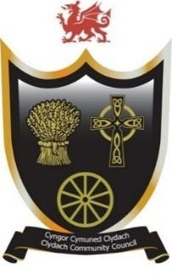
Cyngor Cymuned Clydach
Clydach Community Council
Forge Fach Community Resource Centre
Hebron Road, Clydach. SA6 5EJ
Tel 01792845566
Email clerk@clydach.wales

To Members of the Committee, you are hereby summoned to attend the meeting of the EVENTS AND PROJECT COMMITTEE
To be held at Waterfall Suite, Forge Fach Resource Centre
and as a VIRTUAL MEETING ONLINE
On Tuesday 13 January 2026, commencing at 6.00 pm
Michaela Chaplin
CLERK TO THE COUNCIL
__________________________________________________________________

Members of the Council or Public and Press who wish to attend the meeting online MUST inform the Clerk in writing by 12 Noon on Tuesday 13th January
___________________________________________________________________
Committee Members: Cllrs: Eve Jackson (Chair), John Hill, Dylan Williams,
Caiden Thomas, Siubhan Evans-Jones, Steve Weller, Melissa Farr, Leah Haines.
Agenda

- To receive apologies for absences
- To approve new members to the committee
- To receive Declarations of interest
- To consider matters raised by members of the public related to items on the
agenda, limited to 10 mins
- To receive the Finance report
- To discuss the remaining budget for 2025/2026
- To discuss and approve event calendar for the rest of 2025/2026
- To discuss and approve event calendar for 2026/2027
- To discuss the budget for 2026/2027
- To discuss planters
- To discuss any projects
- Date of next meeting – 10 February 2026

