Reporting on Section 6
Community and Town Councils

Environment (Wales) Act 2016 Part 1 – Section 6
The Biodiversity and Resilience of Ecosystems Duty

The Biodiversity and Resilience of Ecosystems Duty
Report 2025
Name of Community or Town Council: | Clydach Community Council
Group: | 2
Introduction and Context
Clydach Community Council provides a range of services to its local community and recognises its role in supporting local biodiversity.

These include:
• Responsibility for Waverley Park, a grassed area with benches on the perimeter. Small wooded area in corner of field. Cae Charles, a grassed field with wildflowers growing running along side the Lower Clydach River ending at the weir / waterfall. Vardre Community Hall, which is also the home to Clydach Community Gardens. Forge Fach Resource Centre which also houses a children’s play area. Which it reviews and adapts its management practices where appropriate
• Liaising with and supporting a few community groups in its area who are involved in environmental matters. Including Clydach Community Gardens which are housed in the grounds of Vardre Community centre.
• Helping to raise awareness of biodiversity and environmental matters by supporting or organising relevant events, including with The River Trust.
• Providing funding where possible for projects in the Council’s area which impact on biodiversity.
The Council promotes sustainability and biodiversity by pursuing sustainability goals and sustainable practices whenever possible.

The primary reporting responsibility rests with the Clerk to the Council, with policy decisions
determined by Council and individual Members contributing to implementation as appropriate

The Council serves approximately 8,400 (ONS 2022) residents in the communities of Clydach, Vardre, Glais and Graigfelen. The precept for 2025-2026 is £179,205.

The local area has a history of coal mining; tin plate works and other heavy industry. Clydach is
centred around the confluence of the Lower Clydach River and the River Tawe, and the disused
Swansea canal runs through the area.

This report summarises completed initiatives, ongoing commitments, and planned future actions.

Action Report 2023 - 2025
NRAP  Objective | Action carried out to… |  | Monitored by:
1 | -embed biodiversity into decision making & procurement | The biodiversity officer from OVW has attended the site and provided a report which will be taken forward with decisions made by the council.  The biodiversity impact is considered in future decisions of the council for example the carpark lights are being upgraded to LED to enhance energy saving and on a timer to reduce amount of time and reduce light pollution. Cleaning products used within the buildings are being reassessed and all events consider its impact on the environment before, during and after the event occurs. | Clerk to the Council
1 | -raise awareness of biodiversity & its importance | Several councillors have attended Biodiversity training that has been offered by OVW.  A group of councillors attended an event at Celtic Wildflowers to learn what plants would be suitable for the area.  The councils Facebook page and website are used to publish events. | Clerk to the Council
2 | -safeguard principal species and habitats | Ensuring that Intrusive non-native plants are managed as required. | Clerk to the Council
3 | -restore & create habitats and resilient ecological networks | The meadow area at Cae Charles has been left as there was already evidence of Common knapweed, Red clover, Hares foot clover, Bedstraws, Meadow buttercup, Common fleabane, Hedge woundwort, Self-heal  Sedges, sorrels, and plantains.  Bulbs have been planted in the grounds of Forge Fach Resource centre and Vardre Community Centre.  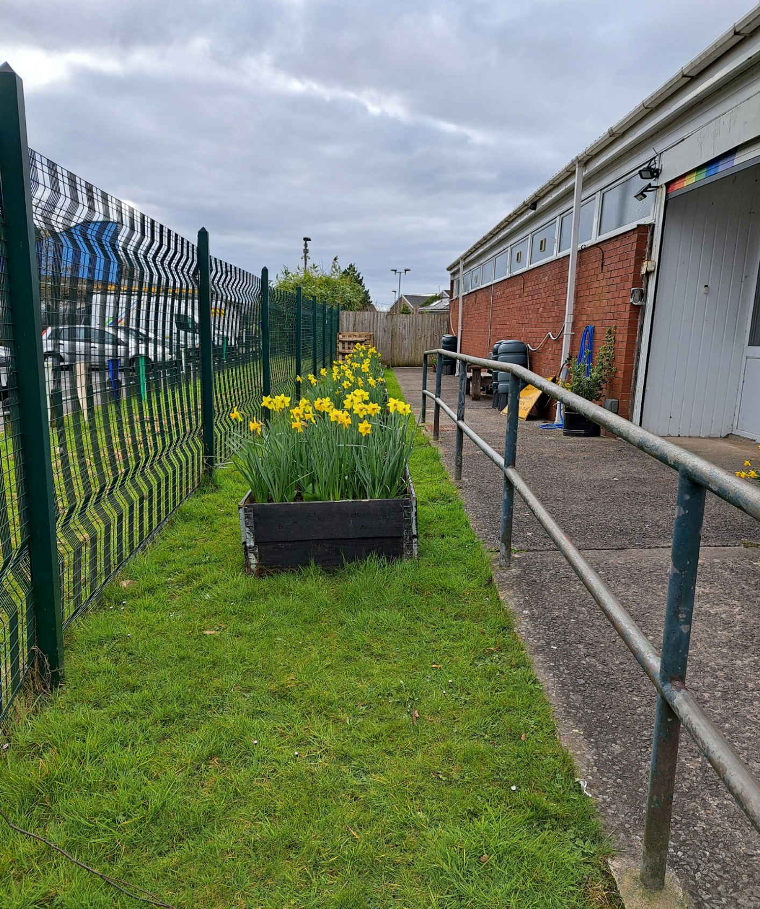  A Local Places for Nature - Keep Wales Tidy pack was received and planted by councillors and volunteers.  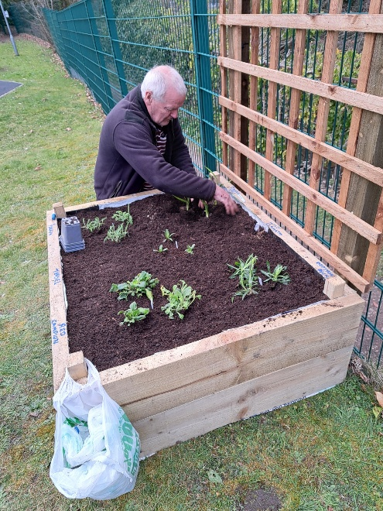  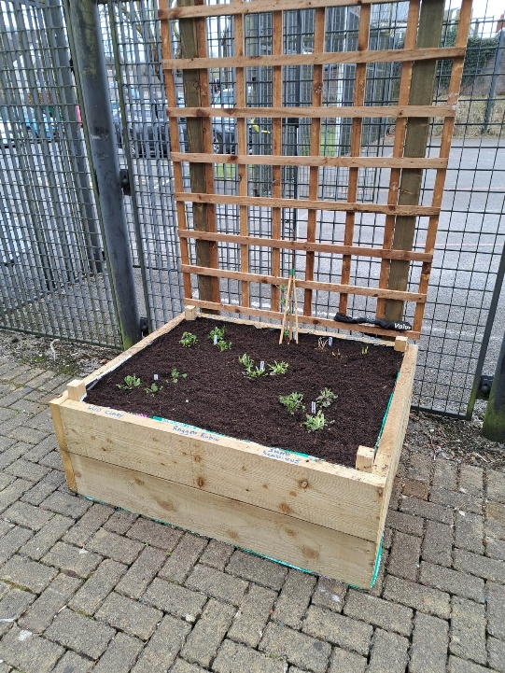  We are responsible for many planters down the high street in Clydach. | Clerk to the Council
4 | -tackle negative factors: for e.g. reduce pollution, use nature based solutions, address invasive species | There are large areas of Himalayan balsam and Japanese Knotweed, which are Invasive Non-Native Species. We are working in partnership with The Rivers Trust in trying to remove these.  Balsam pulling and cutting has taken place regrowth has occurred rapidly. Japanese Knotweed treatment has occurred, and further treatments planned for 2026. 95% of the Japanese Knotweed in Cae Charles area was treated with over 600 litres of water mixed with herbicide being used in the process.  We encourage recycling within our centres and provide recycling bins for all our tenants. | Clerk to the Council
5 | -use improve and share evidence | Council’s use of Facebook has allowed progress in engagement and  publicity of the Council’s initiatives and of the need to promote biodiversity. | Clerk to the Council

6 | -support capacity and/or other organisations | Clydach Community Garden was using a small part of the ground within the Vardre community centre compound, with the support of the council this area has expanded and will be continuing to expand into 2026.  Working in partnership with The River Trust there have been several successful events including balsam bashing, litter picking and nature walks. This will be developed further in 2026 with a programme of events running from April to October and a Riverside festival in the summer. | Clerk to the Council

Review of S6 duty actions for 2023-2025
What has worked well? | The commitment shown by Members and staff has been commendable to date.  Understanding that this is a “duty” that falls on the Community Council and that there are reporting obligations has been absorbed in the Council’s work programme.  Officers and Members engage with partners.
What have the barriers been? | Change of office staff has impeded in the continued efforts. Time has been a factor and understanding.
What will you change? | Encouragement for more councillors and staff to attend the biodiversity training offered by OVW.  Engaging with partners to help enhance the councils land and the surrounding Clydach Community Council area.  Considering biodiversity elements of all events and working with vendors to ensure we all do the best we can.  Having a councillor who acts as a Biodiversity champion with all matters within the council.  Creating a Biodiversity plan that will enable progress and implementation to be monitored better. Ensuring that all ideas are heard and have a chance to develop.
How and when will the s6 duty be monitored and the s6 plan reviewed? | Many ideas have been generated and will be included in the Biodiversity Action plan for 2026 onwards. The creation of an Action Plan will allow for better ownership of projects and monitoring of progress.  The S6 plan will be monitored on going.

