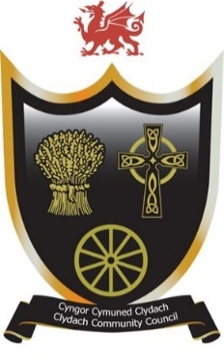
Cyngor Cymuned Clydach
Clydach Community Council
Forge Fach Community Resource Centre
Hebron Road, Clydach. SA6 5EJ
01792 845566
clerk@clydach.wales

To the Members of Clydach Community Council
You are hereby summoned to attend a Staffing Committee Meeting
To be held at Waterfall Suite, Forge Fach Resource Centre
and as a VIRTUAL MEETING ONLINE
on
Tuesday, 3 February 2026 at 6:30 PM

Members of the Council, Press and Public are welcome to attend

Michaela Chaplin
CLERK TO THE COUNCIL
___________________________________________________________________________
AGENDA
- To receive apologies for absences
- To receive Declarations of interest
- To consider passing a resolution that further to Subsection (1) of Section 2 of the Public Bodies (Admission to Meetings) Act 1960, the public and press be excluded from the meeting during the following three items by virtue of the nature of business to be transacted.
- To discuss staffing matters

