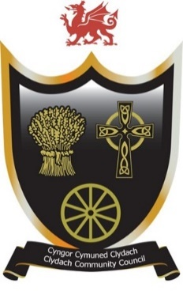
Cyngor Cymuned Clydach
Clydach Community Council
Forge Fach Community Resource Centre
Hebron Road, Clydach. SA6 5EJ
01792 845566
clerk@clydach.wales

To Members of the Committee, you are hereby summoned to attend the meeting of the FINANCE AND AUDIT COMMITTEE
To be held at Waterfall Suite, Forge Fach Resource Centre
and as a VIRTUAL MEETING ONLINE
On Tuesday 12 May 2026 commencing at 7.30pm
Michaela Chaplin
CLERK TO THE COUNCIL
__________________________________________________________________

Members of the Council or Public and Press who wish to attend the meeting online MUST inform the Clerk in writing by 12 Noon on Tuesday 12 May 2026
___________________________________________________________________

Committee Members: Jason Price, Steve Weller, Julian Nicholds, Sue Powell, Eve Jackson and Melissa Farr

AGENDA

- To receive apologies for absences
- To receive Declarations of interest
- To consider matters raised by members of the public related to items on the
agenda, limited to 10 mins
- To receive the Clerk’s report for the financial year ending 31 March 2026
- To consider and discuss proposed budget amendments for 2026–2027
- To confirm date of next meeting

